Microservices Collaboration

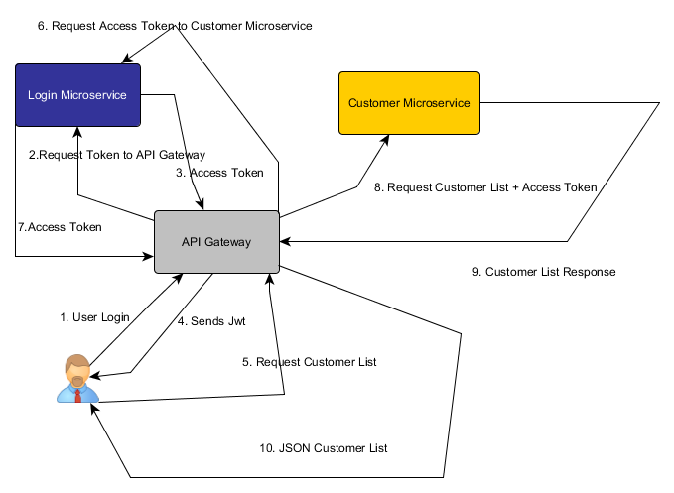

# Login Microservice

Login Micro service is built isolated from other services serving as an Authority Server by using the Nuget Package **IdentityServer4.**

Concepts around the Identity Server:

* ***Clients***: Clients applications that want to access secured resources.
* ***Scopes***: The resources that a client can access. It is used to perform security from microservice to microservice communications.
* ***Users***: Application Users.

That information is in-memory which is a feature offered by IdentityServer4 framework.

There are setup 2 clients:

* ***web.client***: Its used to access the API Gateway from the Front end.
* ***api.gateway.client***: Its used to request tokens to access microservices allowed in scopes for the API Gateway which will be the main entry point in the application.

There are setup two api resources:

* api_gateway: Permissions to use the api gateway. Its evaluated by introspective functionality.
* api_customers: Permissions the api.gateway.client needs to access the customers microservices. If not present the customers microservices will return a 403 forbidden error message.